1. And thou, most kind and gentle death,

Waiting to hush our latest breath,

O praise him, Alleluya!

Thou leadest home the child of God,

And Christ our Lord the way hath trod:

*O praise him, O praise him,*

*Alleluya, Alleluya, Alleluya!*

1. Let all things their Creatory bless,

And worship him in humbleness,

O praise him, Alleluya!

Praise, praise the Father praise the Son,

And praise the Spirit, three in one:

*O praise him, O praise him,*

*Alleluya, Alleluya, Alleluya!*

1. Dear mother earth, who day by day

Unfoldest blessings on our way,

O praise him, Alleluya!

The flowers and fruits that in thee grow,

Let them his glory also show:

*O praise him, O praise him,*

*Alleluya, Alleluya, Alleluya!*

1. And all ye men of tender heart,

Forgiving others, take your part,

O sing ye, Alleluya!

Ye who long pain and sorrow bear,

Praise God, and on him cast your care:

*O praise him, O praise him,*

*Alleluya, Alleluya, Alleluya!*

**The Blessing**

*The South Downs Natural Burial Site*

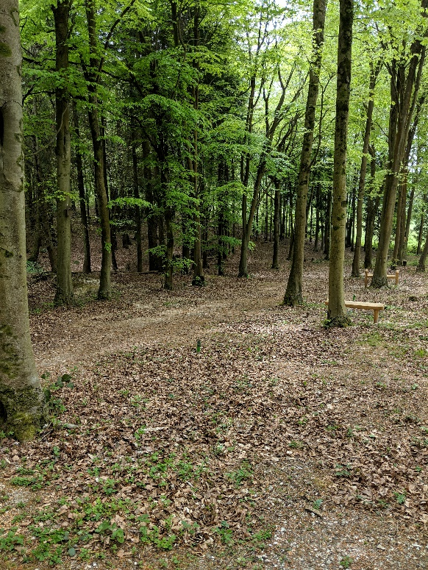

**Funeral and Service of Thanksgiving for the life of**

**Chris Clarke**

**Church of St Michael the Archangel**

**Southampton**

**Friday 3 May 2019**

**1.30pm**

Minister: Rev Phil Hand

Organist: Duncan Bradley



**Funeral and Service and Thanksgiving for the life of Chris Clarke**

St Michael’s Church, Southampton

*Friday 3 May 2019, 1.30pm*

**Opening sentences and welcome**

**Hymn**

1. O Thou who camest from above,

The pure celestial fire to impart,

Kindle a flame of sacred love

On the mean altar of my heart.

1. There let it for thy glory burn

With inextinguishable blaze,

And trembling to its source return

In humble prayer, and fervent praise.

1. Jesus, confirm my heart’s desire

To work, and think, and speak for thee;

Still let me guard the holy fire,

And still stir up the gift in me.

1. Ready for all thy perfect will,

My acts of faith and love repeat,

Till death thy endless mercies seal,

And make my sacrifice complete.

**Collect**

**Reading** – **Proverbs 8:22-31**

**Tributes to Chris Clarke –** *Isabel, Leon and Dunstan Clarke*

**Reading – Psalm 104:1-6, 16-19, 33-34**

**Sermon**

**Prayers**

During the prayers, the response is:

Lord in your mercy,

**Hear our prayer**

And at the end we all say:

**God of mercy,**

**entrusting into your hands all that you have made,**

**and rejoicing in our communion with all your faithful people,**

**we make our prayers through Jesus Christ our Saviour.**

**Amen.**

**t**

**The Lord’s Prayer**

As our saviour taught us, so we pray:

**Our Father in Heaven**

**hallowed be your name,**

**your kingdom come**

**your will be done**

**On earth as in heaven.**

**Give us today our daily bread,**

**and forgive us our sins,**

**as we forgive those who sin against us.**

**Lead us not into temptation,**

**but deliver us from evil.**

**For the kingdom, the power**

**and the glory are yours**

**Now and forever**

**Amen.**

**Commendation and farewell**

**Hymn**

1. All creatures of our God and King,

Lift up your voice, and with us sing

Alleluya, Alleluya!

Thou burning sun with golden beam,

Thou silver moon with softer gleam:

*O praise him, O praise him,*

*Alleluya, Alleluya, Alleluya!*

1. Thou rushing wind that art so strong,

Ye clouds, that sail in heaven along,

O praise him, Alleluya!

Thou rising morn, in praise rejoice,

Ye lights of evening, find a voice:

*O praise him, O praise him,*

*Alleluya, Alleluya, Alleluya!*

1. Thou flowing water, pure and clear,

Make music for thy Lord to hear,

Alleluya, Alleluya!

Thou fire, so masterful and bright,

That givest man both warmth and light:

*O praise him, O praise him,*

*Alleluya, Alleluya, Alleluya!*